Standard Operating Procedure
Running the Clinical Trials Change Detection Tool
ct_change_detection.py — CT.gov Extraction → Enrichment → Change Comparison

1. Purpose
This SOP explains how to run the Clinical Trials Change Detection tool for MASH CI. No coding knowledge is required. The tool automatically:
- Searches ClinicalTrials.gov for every asset/program listed in Search_Queries.xlsx and collects the matching NCT IDs.
- Enriches each unique NCT ID with the full 119-field trial detail set from the CT.gov API.
- Compares that fresh dataset against a previous extraction and highlights exactly what changed — new trials, removed trials, and any changed field.
The end result is a single Excel report with changed cells highlighted yellow, new trials highlighted green, and a summary sheet listing everything that changed or was removed.

2. Before You Start (One-Time Setup)

2.1 Install Python
If Python is not already installed on your laptop:
- Download Python 3.10 or later from https://www.python.org/downloads/
- During installation, tick the checkbox “Add Python to PATH” before clicking Install.
Skip if already done: If someone in IT has already set up Python on your machine, or you have run this tool before, skip to section 2.2.

2.2 Install the Required Python Packages
Open Command Prompt (search “cmd” in the Windows Start menu) and run the single command below. This only needs to be done once per laptop:
pip install requests openpyxl
What each package is for:
- requests — calls the ClinicalTrials.gov v2 API to search for trials and pull full trial details (only needed if you run a fresh extraction; not needed to simply compare two files you already have)
- openpyxl — reads and writes the .xlsx report files, including the yellow/green highlighting
Alternative one-liner: You can also run “pip install -r requirements.txt” from inside the Change detection_Scripts folder — it installs the exact same two packages, pinned to tested version ranges.

2.3 Check the Search Query List
The file Search_Queries.xlsx (inside the Scripts folder) lists every asset/trial program the tool searches for, with two columns: “Asset/Trial Program” and “Asset String only” (the actual search string sent to ClinicalTrials.gov). Add a new row here any time a new asset needs to be tracked — no code changes are required.

3. Running the Tool

Step 1 — Launch the tool
Go to the Change detection_Scripts folder and double-click:
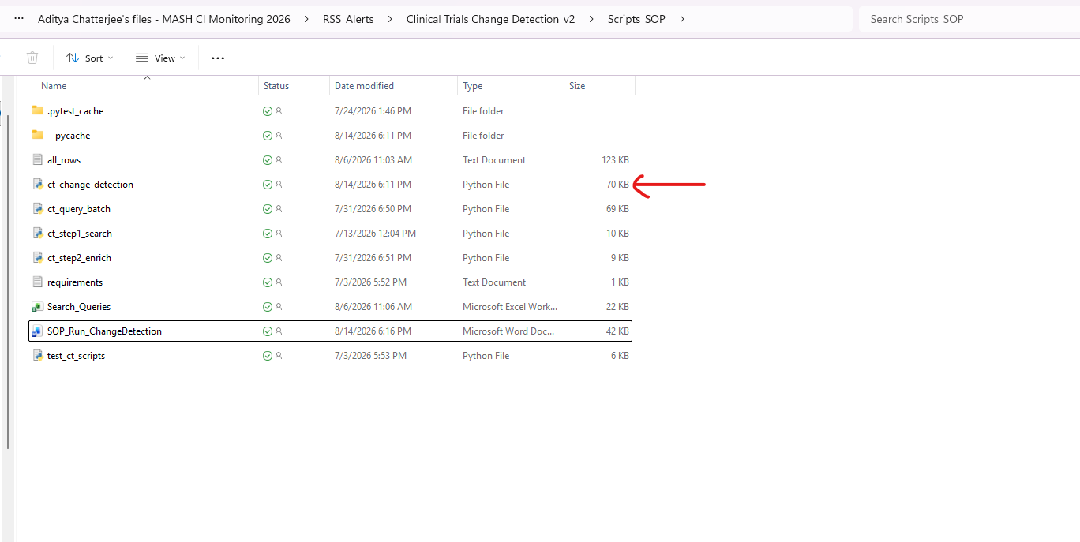
ct_change_detection.py
A black command-window will open showing the tool's progress. Do not close it while it is running.

Step 2 — Choose a mode
You will see:
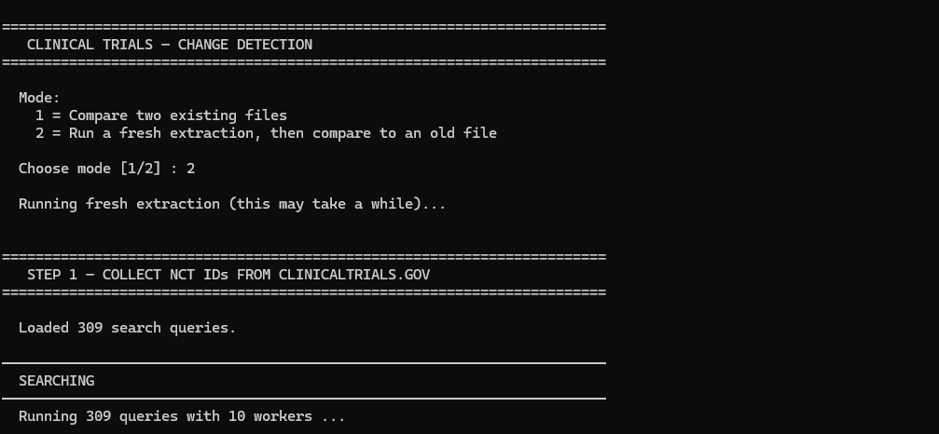
Mode:
1 = Compare two existing files
2 = Run a fresh extraction, then compare to an old file
Choose mode [1/2] :
Mode | When to use it | What happens next
1 | You already have two exported files (e.g. last week's and this week's) and just want them compared. | A file-picker window opens for the OLD file, then a second one for the NEW file.
2 | You want the tool to pull the latest data from ClinicalTrials.gov right now and compare it against a previous export. This is the normal weekly/periodic run. | The tool runs Step 1 (search) and Step 2 (enrich) automatically — this can take several minutes — then opens a file-picker window for you to select the OLD file to compare the fresh data against.

Step 3 — Select the file(s) when asked
- A standard Windows “Open file” window appears. Browse to the file, click it, and click Open — there is no need to type or paste a path. The window opens in the CT_Exports folder by default and lists Excel files (*.xlsx, *.xlsm).
- If you click Cancel in the file-picker window, the tool stops without producing a report — nothing is changed. Just re-launch it to start again.
- The OLD file is your previous extraction (e.g. last week's Step2_Final_Dataset_*.xlsx from CT_Exports). The NEW file (Mode 1 only) is the more recent one you want to compare it against.
Tip: The most recent extractions always live in the CT_Exports folder — sort that folder by "Date modified" to quickly find the OLD file you need.

Step 4 — Let it run
The tool reads both files' “Deduplicated” sheet, matches trials by NCT ID, and compares every field (except a few constant/noisy columns like the CT.gov link). Progress and a results summary print directly in the window, for example:
── Results ──
Unchanged : 412
Changed : 7 (cells highlighted yellow)
New : 2 (rows highlighted green)
Removed : 1 (see Change Summary sheet)

Step 5 — Open the report
When finished, the tool prints where it saved the report and pauses on “Press Enter to close...”. The report is saved to:
Change_Reports\Change_Report_YYMMDD_HHMMSS.xlsx
Open that file in Excel. It contains:
- The full comparison sheet — changed cells highlighted yellow, brand-new trial rows highlighted green.
- A “Change Summary” sheet listing every changed field (old value vs. new value) and any trials that were removed since the OLD file.

4. Running Individual Steps (Optional, Advanced)
The three building blocks below run automatically inside ct_change_detection.py Mode 2. You would only run them manually if you need to debug one stage on its own:
Script | What it does | Output
ct_step1_search.py | Searches CT.gov for every query in Search_Queries.xlsx, collects matching NCT IDs. | CT_Exports\Step1_NCT_IDs_YYYYMMDD_HHMMSS.xlsx
ct_step2_enrich.py | Enriches the most recent Step 1 file's unique NCT IDs with full trial detail (119 fields). | CT_Exports\Step2_Final_Dataset_YYYYMMDD_HHMMSS.xlsx
ct_query_batch.py | Alternative single-pass batch search/enrich utility. | CT_Exports\CT_QueryBatch_YYYYMMDD_HHMMSS.xlsx

Each can also be double-clicked directly the same way as ct_change_detection.py.

5. Where to Find Your Files
Folder | Contains
CT_Exports | Raw Step 1 (NCT ID search) and Step 2 (enriched dataset) extractions
Change_Reports | FINAL highlighted change-detection reports (use this one)
Archive | Older extractions kept for historical reference

CT_Exports and Change_Reports both sit in the main workflow folder, one level above the Change detection_Scripts folder.

6. Troubleshooting
Symptom | What to do
Window flashes and closes immediately | Right-click ct_change_detection.py → Open with → Python. If Python is not listed, reinstall Python and tick “Add to PATH”.
“ModuleNotFoundError” for requests or openpyxl | Re-run: pip install requests openpyxl
“File not found” when entering a path | This only appears on machines with no graphical file picker, where the tool falls back to asking you to type a path. Double-check the path, or drag-and-drop the file from File Explorer into the command window instead of typing it.
Mode 2 fails during Step 1 or Step 2 | The tool aborts rather than comparing against stale data. Re-run Mode 2 — this is often a transient ClinicalTrials.gov API hiccup.
A new asset never shows up in results | Confirm it has a row in Search_Queries.xlsx with a valid search string in “Asset String only”.

7. Quick Reference Card
What | How
One-time install | pip install requests openpyxl
Start a run | Double-click Change detection_Scripts\ct_change_detection.py
Normal/periodic run | Choose Mode 2, then pick the OLD file in the file-picker window
Comparing two files you already have | Choose Mode 1, then pick the OLD file, then the NEW file
Add a new asset to track | Add a row to Search_Queries.xlsx (no code changes needed)
Final report location | Change_Reports folder

